**DAILY ONLINE ACTIVITIES SUMMARY**

|  |  |  |  |  |  |  |  |  |
| --- | --- | --- | --- | --- | --- | --- | --- | --- |
| **Date:** | **4th june,2020** | | | | | **Name:** | **Prathusha K A** | |
| **Sem & Sec** | **4th sem &b section** | | | | | **USN:** | **4AL18CS061** | |
| **Online Test Summary** | | | | | | | | |
| **Subject** | | **Microcontroller and embedded systems.** | | | | | | |
| **Max. Marks** | | **20** | | **Score** | | | **16** | |
| **Certification Course Summary** | | | | | | | | |
| **Course** | **Programming for everybody (getting started with python)** | | | | | | | |
| **Certificate Provider** | | | **Coursera** | | **Duration** | | | **7 weeks** |
| **Coding Challenges** | | | | | | | | |
| Problem Statement: Write a C++ program to find the missing number in array. | | | | | | | | |
| **Status: done** | | | | | | | | |
| **Uploaded the report in Github** | | | | | **yes** | | | |
| **If yes Repository name** | | | | | **https://github.com/prathu47/lockdown-coding** | | | |
| **Uploaded the report in slack** | | | | | **yes** | | | |

Online Test Details: (Attach the snapshot and briefly write the report for the same)

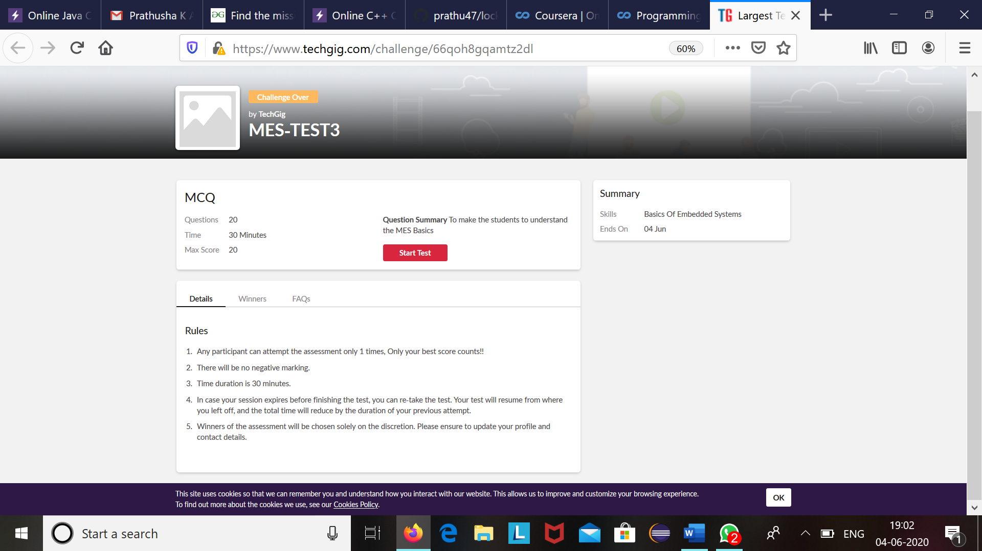

MES internals was conducted today .A total of 20 questions which is of mcq. Started at 2:00 PM and ended at 2:30 each carries one mark.

The above snapshot is the result sheet which was sent to us by the Techgig team.

Certification Course Details: (Attach the snapshot and briefly write the report for the same)

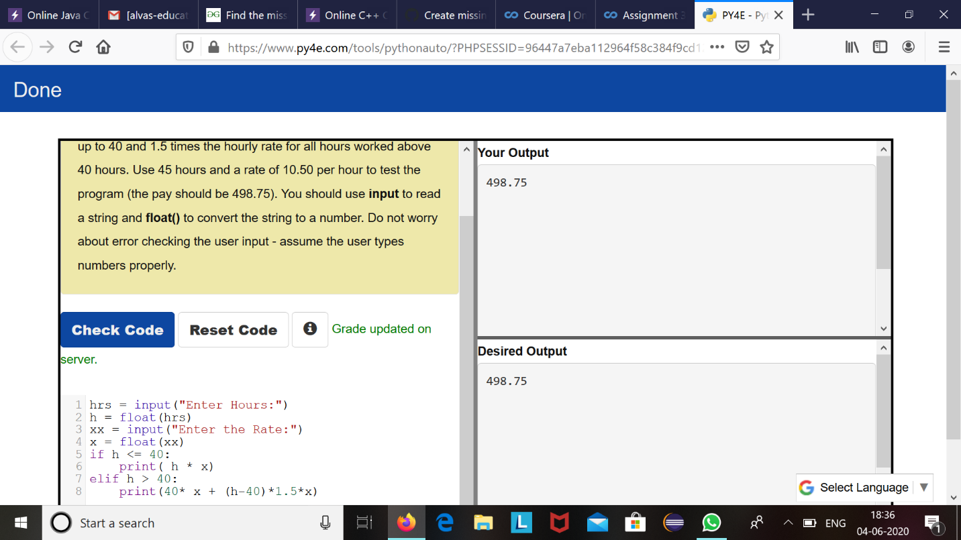

The course I have chosen during the lockdown period is programming for everybody. Since I had previously knew few topics about python iam continuing this course. Since python is gaining a lot of interest in coding platform I have preferred to choose this course.

Coding Challenges Details: (Attach the snapshot and briefly write the report for the same)

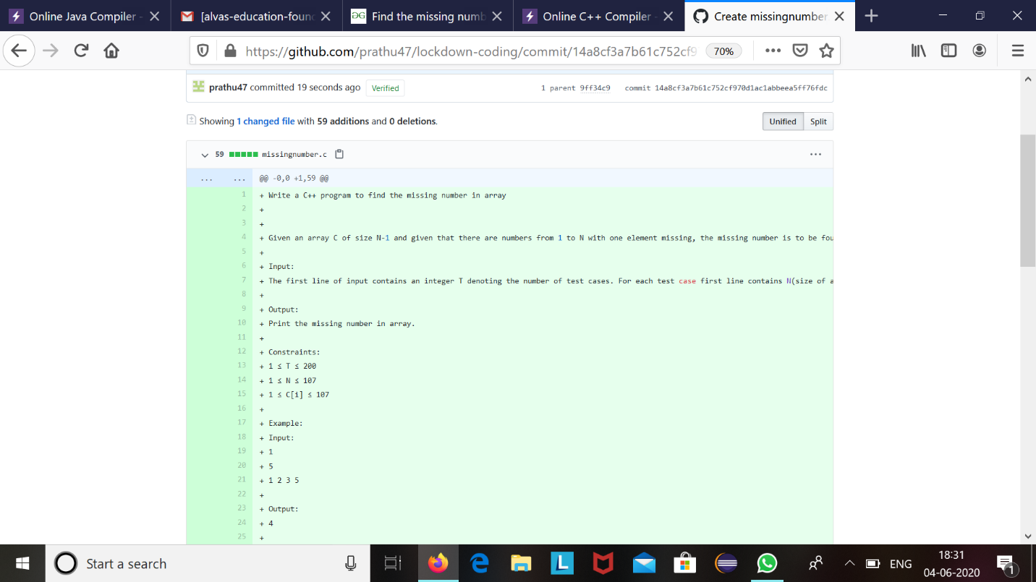

The question we had received today was

Write a C++ program to find the missing number in array

Given an array C of size N-1 and given that there are numbers from 1 to N with one element missing, the missing number is to be found.

**Input:**  
The first line of input contains an integer T denoting the number of test cases. For each test case first line contains N(size of array). The subsequent line contains N-1 array elements.

**Output:**  
Print the missing number in array.

**Constraints:**  
1 ≤ T ≤ 200  
1 ≤ N ≤ 107  
1 ≤ C[i] ≤ 107

Example:  
Input:  
1  
5  
1 2 3 5

Output:  
4

Code:The above snapshot is the code which I have uploaded in my github repository.